62.
a) $2x+y=7$ /5
$$3x-5y=4$$
$$10x+5y=35$$
$$3x-5y=4$$
$$13x=39$$
$$x=3$$
$$6+y=7$$
$$y=7-6=1$$
Rješenje (3,1)

b) $4x-2y=-2$
$2x-3y=-5$ /(-2)
$$4x-2y=-2$$
$$-4x+6y=10$$
$$4y=8$$
$$y=2$$
$$4x-4=-2$$
$$4x=2$$
$x=\frac{1}{2}$
Rješenje ($\frac{1}{2},2)$

c) $6x-10y=11$
$\frac{1}{3}x-2y=1$/(-5)
$$6x-10y=11$$
$-\frac{5}{3}x+10y=-5$
$$\frac{13}{3}x=6$$
$x=\frac{18}{13}$
$\frac{6}{13}-2y=1$
$-2y=\frac{7}{13}$
$y=-\frac{7}{26}$

d) $12x-4y-9x+6=-5$
$25y+10x-14-6y=-15x-1$
$3x-4y=-11$ /19
$25x+19y=13$ /4
$57x-76y=-209$
$100x+76y=52$
$157x=-157$
$x=-1$
$-3-4y=-11$
$-4y=-8$
$y=2$
Rješenje (-1,2)

63. a) y =x – 3
y = -3x -11 (-1)
y = x- 3
-y=3x+11
0=4x+8
4x=-8
x=-2
y=-2-3 = - 5
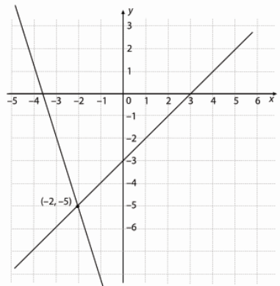
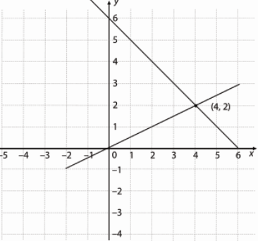
b) $y=\frac{1}{2}x$
$y=-x+6$ /(-1)
$y=\frac{1}{2}x$
$-y=x-6$
$0=\frac{3}{2}x-6$
$\frac{3}{2}x=6$
$$x=4$$
$$y=-4+6=2$$

63.
a) x+y=7
2x-y=2
3x=9
x=3
y = 7-x=7-3=4
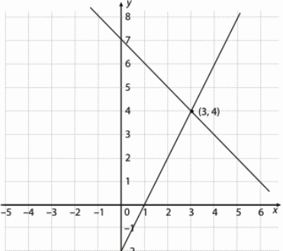
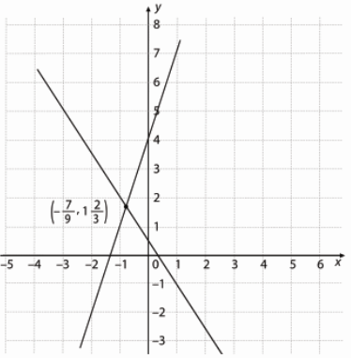
b) -3x+y=4
3x+2y=1
3y=5
$y=\frac{5}{3}$
$3x+\frac{10}{3}=1$
$3x=-\frac{7}{3}$
$x=-\frac{7}{9}$

65.
a) -2x+y= -3
2x+y =3
2y=0
y=0
x=1.5
(1.5,0)
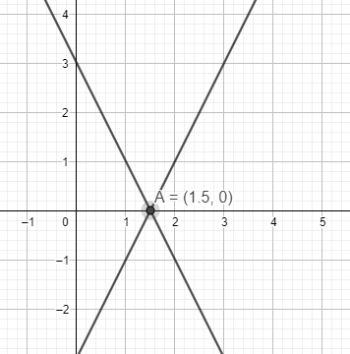
b) y=-x+3
x+y-1=0
y=-x+1
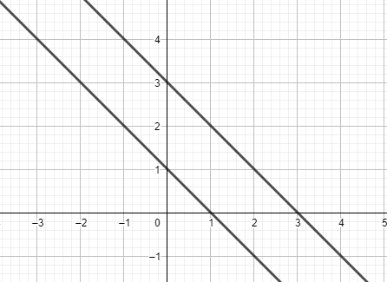
Nema rješenja.

c) $y=\frac{3}{4}x-1$
$8y=6x-8$
$y=\frac{3}{4}x-1$
Beskonačno rješenja.
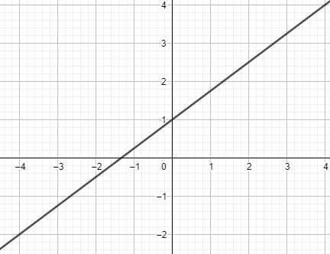
66.
a)1 rješenje
b) 1 rješenje
c) nema rješenja
d) 1 rješenje
e) 1 rješenje
f) beskonačno rješenja
g) nema rješenja
h) beskonačno rješenja

67.
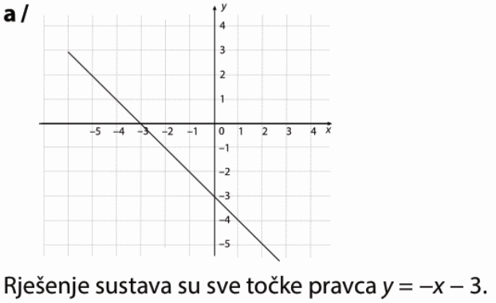
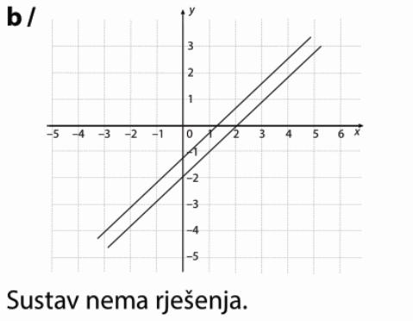

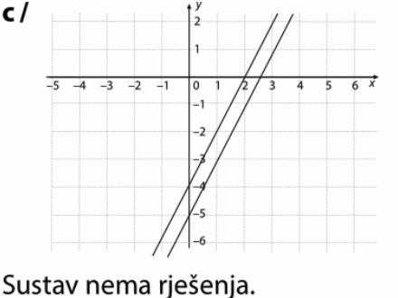

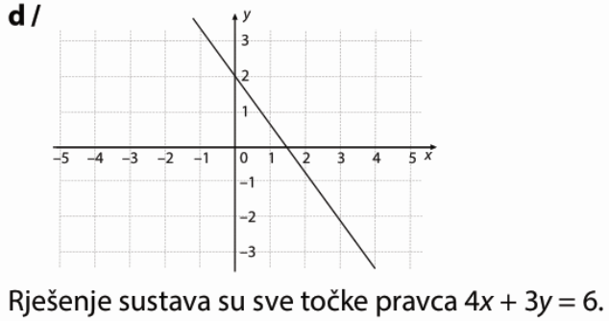

68.
a)
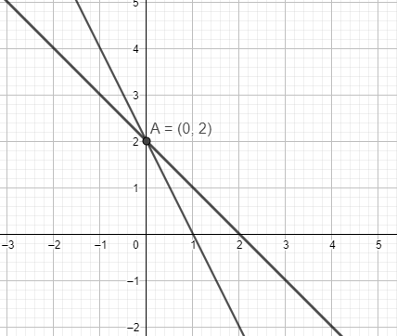

b)
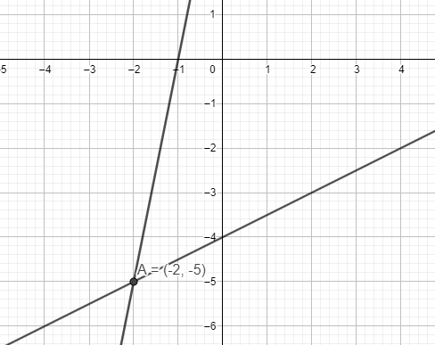
c)
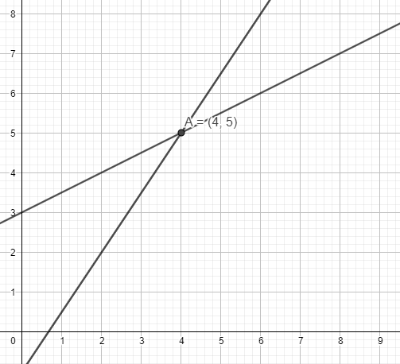
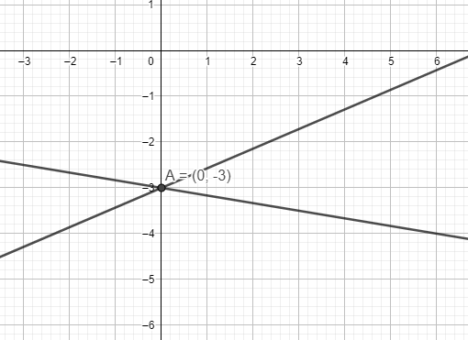
d)

69.
a) 1 rješenje
b) nema rješenja
c) beskonačno rješenja
d) beskonačno rješenja

70.
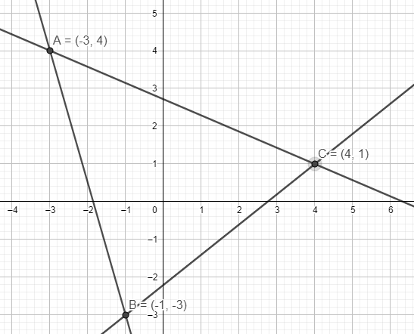
71.
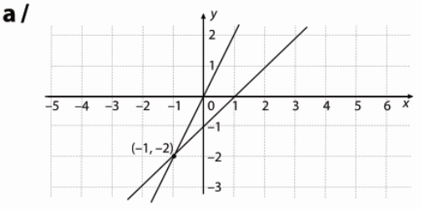
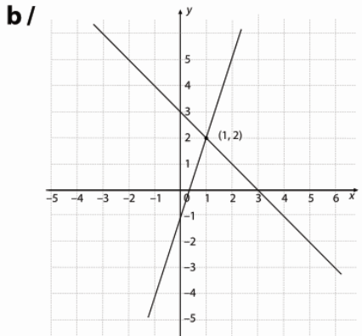
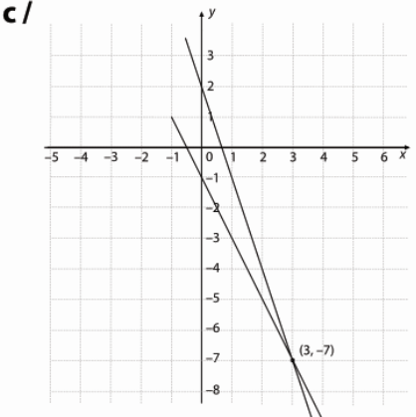
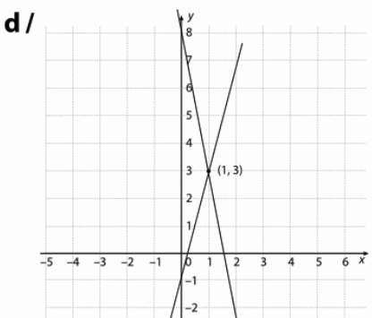
72.
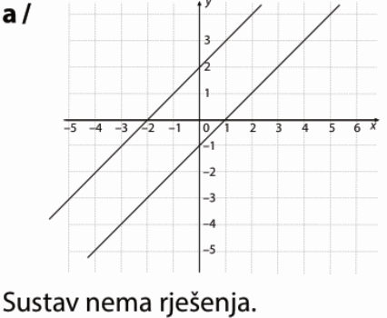
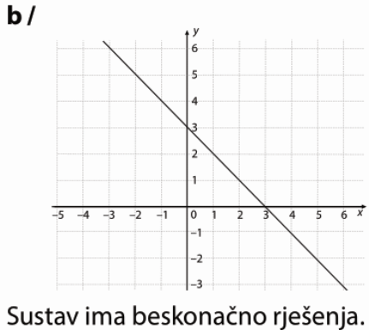
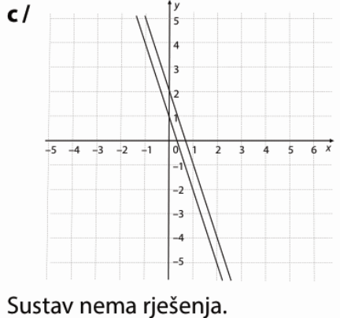

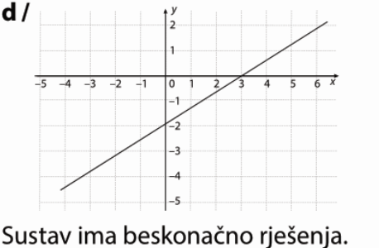
73.
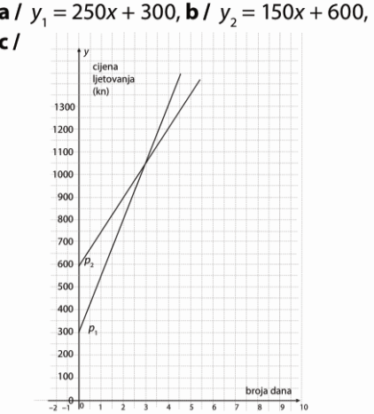
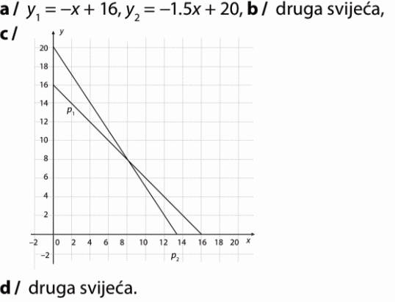
74.

d) $y_{1}=250∙2+300=500+300=800$
$$y_{2}=150∙2+600=300+600=900$$
Prva je povoljnija.

e) $y_{1}=250∙6+300=1500+300=1800$
$$y_{2}=150∙6+600=900+600=1500$$
Druga.

f) 250x+300=150x+600
250x-150x=600-300
100x=300
x=3
Tri dana.

75.
a) G=g · m=10N/kg · m
b) $G_{m}=\frac{1}{6}g_{Z}∙m$
e) $G_{m}=\frac{1}{6}∙695N=115.83 N$

76.
a) $y_{M}=50x+600$
$$y_{I}=100x+400$$

c) 50x+600=100x+400
50x =200
x = 4
Nakon 4 mjeseca.
78.
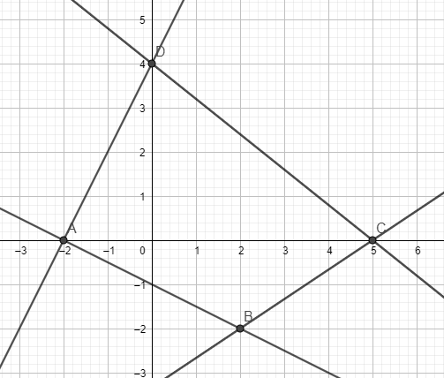
$P=P_{∆ABC}+P_{∆CDA}=\frac{7∙2}{2}+\frac{7∙4}{2}=7+14=21$ kvadratnih jediničnih dužina

